04th March 2020

New Yokohama Tyre products for 2020 announced

Yokohama Europe has today presented via a virtual press conference a new range of winter and summer products for the European market.

The planned contents of the Geneva Motor Show press conference have been condensed to a video presentation which was offered to the media by a live stream and is now also available on the YOKOHAMA Europe website.

Due to the cancellation of the Motor show, YOKOHAMA’s planned conference did not take place but as a Japanese premium tyre manufacturer YOKOHAMA is keen to showcase its latest and future technology which includes ultra-lightweight and aerodynamic technology, anti-puncture technology, Noise reducing silent technology as well as intelligent tyre concept data transmission from the tyre to the driver.

In addition, the focus points and direction of the company was presented which is to be a global tyre supplier for premium cars, become the number 1 in winter tyre performance and the number 1 manufacturer for “hobby” tyres.

The four new products for 2020 are: 2 Winter products, the BluEarth*Winter V906, a passenger car tyre which improves performance on snow and ice and wet-grip performance - while also maintaining a high level of wear resistance. As a world premiere, the new tyre will be available from this autumn.

The second winter product launched as a European premiere is the iceGuard Studless iG53. This is a studless tyre for passenger cars developed using YOKOHAMA’s latest studless tyre technology and its cutting-edge BluEarth technologies.

In terms of summer products, the first of two tyres launched as European premiere are the BluEarth GT AE51 with a Grand Touring spirit, offering reliable driving by enhancing stability at high speeds while also providing improved wet grip performance and high fuel-saving properties.

The second summer product is the new Geolandar CV G058 aimed at the Crossover SUV and offers better performance in wet as well as a better ride comfort and lower noise. It will be available for the European market from this coming Spring.

YOKOHAMA has had a long and continued commitment to create products which are beneficial to society and can be enjoyed by car enthusiasts.

To view the virtual press conference please click on the link below.

YouTube-Link: https://youtu.be/n7bvDSSxGyg

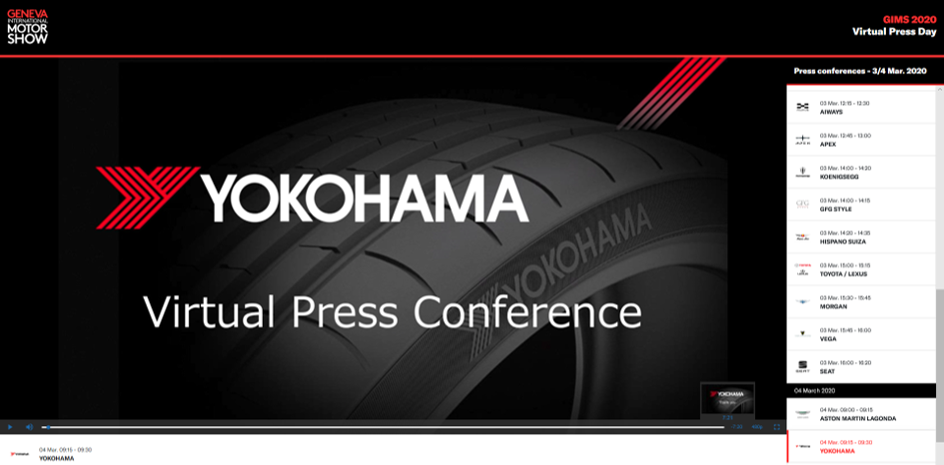

Yokohama Virtual Press Conference 2020

